**Bit Banding**

Bit Banding is used to access a individual bit in the register, memory areas. Be clearly, if we want to change a single bit in the byte/word where the processor can’t do it a lonely. It will be done either by Read Modify Write or Bit banding operations.

By doing with Read modify Write sequences. It needs to read first, then modifies happen and stores the new value. It involves 5 more instruction cycles of three more instructions for single value changes. Suppose if an interrupt occurs between read and modify cycles; the chances of new value will get overwritten; to avoid this the interrupt should be disabled. For this impact concerns, bit banding is introduced by ARM and it using a single instruction to perform a atomic bit manipulation.

**Let we see deeply how's bit banding working**

Bit banding operations are performed in the bit banded regions. As we see the ARM V7 M memory map, there are two lowest 1MB bit band regions is available. One at for SRAM and the other one for Peripherals, like ports and other peripheral register. Within the bit band regions ,we can set or clear the individual bit in the memory regions; This will be done by the bit band alias regions.

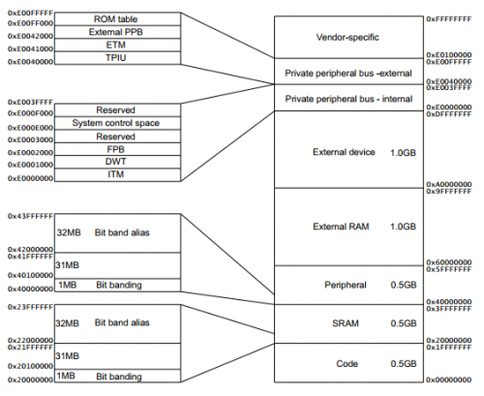

Look into the memory map, there is a two 32MB bit band alias region is available. Bit band alias region is a 32 bit word aligned address. Each bit in the bit band region is consecutively addressed into each 32 bit word of bit band alias region..

Like the following diagram, the bit band region bits mapped into the bit band alias region.

**How to change it**

The bit band alias region has 32 bit word addressed.

To change the value of any individual bitstates either set (0x01)or clear; the value has to be written only at the 0 th bit position which it returns the new value to the respected bit in the bit band region. The restof the bits [31:1] has no effect to the bit band region.

**The formula of bit banding is**

bit_word_offset = (byte_offset * 32) + (bit _number * 4)

bit_word_addr = bit_ band_base + bit_word_offset

where

* bit_word_offset is the position of the target bit in thebit band region.
* bit_word_addr is the word address in the bit band alias region that maps to the targeted bit.
* byte_offset is derived from actual address minus starting address of itr memory section.
* bit_number is the bit position,0-7 of the targeted bit.
* By using this formula we can write macros and program the bit banding in c. The cortex m3has good at c